

# **Chameleon**

# **Task 2.1 P – Company Objective and Structure**

# **Executive Summery**

## Our Mission

Given the complexity of energy application needs today, IoT systems are being designed to address a wide variety of existing problems.

In Chameleon, our mission is to research, create, test, document and deploy IoT-based solutions to enhance life through the application of smart city technologies. Including the building of smarter cities, homes, transportation, and energy management systems.

## Our Structure

There are currently three active divisions within the company (EV will not be running in T3), focusing on the three key areas of strategic importance:

* Security (CS)
* City of Melbourne Open Data (MOP)
* Chameleon Website (CW)

MOP leverage’s datasets from several sources including data generated by IoT-based sensors and as such fit within the goals and mission of the company. The Chameleon website is our main online presence where we articulate who we are, what we do, and show case our projects to the world.

### Security

### City of Melbourne Open Data

The City of Melbourne Open Data Project engages with The City of Melbourne to support a greater use of their Open Data library for businesses, researchers, and software developers. The Melbourne Open Playground (MOP) is an educational portal that demonstrates how to leverage open data using real-world scenarios to assist The City of Melbourne to achieve key strategic goals.

### Chameleon Website

The Chameleon Website aims to accumulate all the information about the Chameleon company and present it in a format that is pleasantly designed, laid out, easy to navigate and displays the progress of each of its three projects and outlines their goals. This project aims to provide a one-stop portal to different links and sub-projects within the company.

# **Leadership Team**

**Acting Director:** Jianxin Li

**Company Board:**

## Security

**Project Lead:**

## Melbourne Open Data Project

**Project Lead:**

## Chameleon Website

**Project Lead:** Aaron James Vandersluys

* Web Development Leads: Mukund Srinivasan, Ratanak Sovann, Kanishk Rajvanshi
* Design Leads: Brodie McCann, Yashika Gagan Arora

## Company Structure

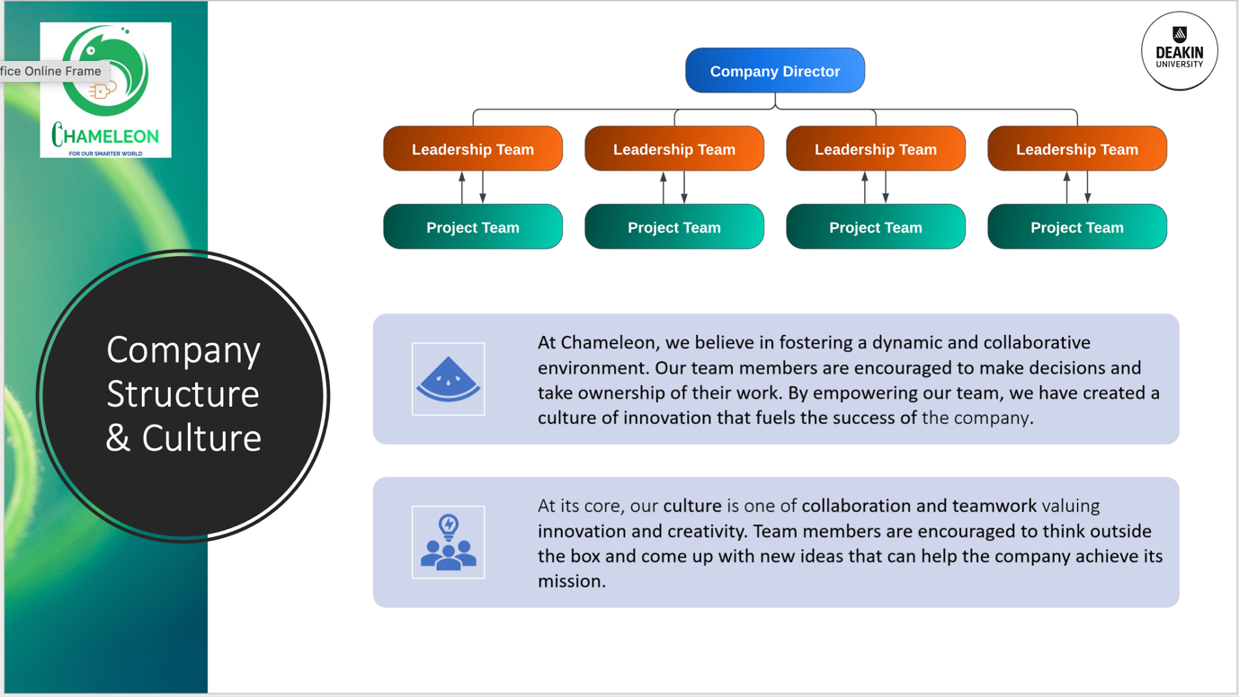

# **Trimester 3 Goals and Objectives**

Describe companywide goals for trimester.

# **Projects Overview**

## Security

**Overview**

**Goals and Objectives**

**Aims This Trimester**

**Deliverables**

**Security Project Team Members**

Insert table of team members including name, student ID, UG or PG, junior / senior, team and leadership status

## Melbourne Open Data Project

**Overview**

**Goals and Objectives**

**Aims This Trimester**

**Deliverables**

**Melbourne Open Data Project Team Members**

Insert table of team members including name, student ID, UG or PG, junior / senior, team and leadership status

## Chameleon Website

**Overview**

The Chameleon website project is a source of information for potential clients and the public to learn about Chameleon and its operations. The Chameleon website will display information relating to Chameleon, its various projects and some resources explaining what IoT technologies are.

**Goals and Objectives**

The Chameleon website aims to provide an accessible single source of information to explain and advocate for Chameleon and its projects, helping to generate interest in the company and its offerings. The Chameleon website aims to be a pleasant experience across a wide variety of screen sizes and devices.

**Aims This Trimester**

The aims for this trimester are to implement an enhanced pop-up notifications system for user accounts on the Chameleon website, to give users a way of quickly receiving new information related to their activities on the Chameleon website, create a responsive design that is scalable across a wide range of devices and screen sizes, ensuring a consistent and pleasant design experience no matter where a user accesses the website.

We also aim to enhance the user experience in other ways, such as adding light and dark mode themes, implementing a support chatbot, and implementing a newsletter system. The design team will contain to refine various visual components, focusing on responsive mobile designs, further use cases and assisting with MOP design. Some web pages will require updates to the underlying technologies to ensure compatibility with the main project (the reset password page is currently not using React JSX).

Lastly, we will enhance the backend by increasing security (adding HTTPS and SSL), migrating from AWS to GCP, and adding a backend database (Firebase currently decided on) to store user account credentials, files and apply SSO options to the website. Incorporating the other projects websites into the main Chameleon website is also being considered to increase the strength of the branding and minimise confusion amongst newcomers, although much of this is undecided on at the time of writing.

**Deliverables**

The following key deliverables have been identified to be required this trimester:

* Complete mobile site designs
* Complete further use cases
* Complete general design refinements
* Implement responsive / mobile designs
* Implement pop up notification system
* Port required pages to React JSX
* Implement dark / light mode theme’s
* Migrate website from AWS to GCP
* Implement backend database (Firebase) for user accounts
* Implement chatbot, picking up from code written in T2
* Implement newsletter service, picking up from code written in T2
* Implement HTTPS and SSL security enhancements
* Port other project websites to main websites codebase (pending deliverable)

**Chameleon Website Project Team Members**

|  |  |  |  |  |  |
| --- | --- | --- | --- | --- | --- |
| **Name** | **Student ID** | **UG/PG** | **J/S** | **Team** | **Lead** |
| Aaron James Vandersluys | 221178806 | UG | Senior | Web Dev | Project Lead |
| Mukund Srinivasan | 219432166 | UG | Senior | Web Dev | Yes |
| Brodie McCann | 219307567 | UG | Senior | Design | Yes |
| Yashika Gagan Arora |  | UG | Senior | Design | Yes |
| Jiaqi Li | 221105067 | PG | Junior | Design | No |
| Hoi Fung Dicky |  | UG | Senior | Design | No |
| Varun Sai Burla | 221013876 | UG | Junior | Design | No |
| Ratanak Sovann | 219339559 | UG | Junior | Web Dev | Yes |
| Kanishk Rajvanshi |  | PG | Junior | Web Dev | Yes |
| Muhammad Rehan Qureshi | 218062706 | UG | Senior | Web Dev | No |
| Arnold Mendis |  | UG | Senior | Web Dev | No |
| Vishnu |  | PG | Senior | Web Dev | No |
| Navin Al Selvaraj |  | UG | Senior | Web Dev | No |
| Yawen (Lora) Liu | 218616602 | UG | Senior | Web Dev | No |
| Aashritha Chakilam | 222453913 | UG | Junior | Web Dev | No |
| Seohee Lee | 222127941 | PG | Junior | Web Dev | No |
| You (Kasey) Wu | 222482192 | PG | Junior | Web Dev | No |
| Uttam Chandu | 220507122 | UG | Junior | Web Dev | No |
| Yi He (Victor) Xiao | 220229302 | UG | Junior | Web Dev | No |
| Aurobindo Mukka | 221013938 | UG | Junior | Web Dev | No |
| Hao Huang |  | PG | Junior | Web Dev | No |